Data Management Week 1
Data Ethics Activity
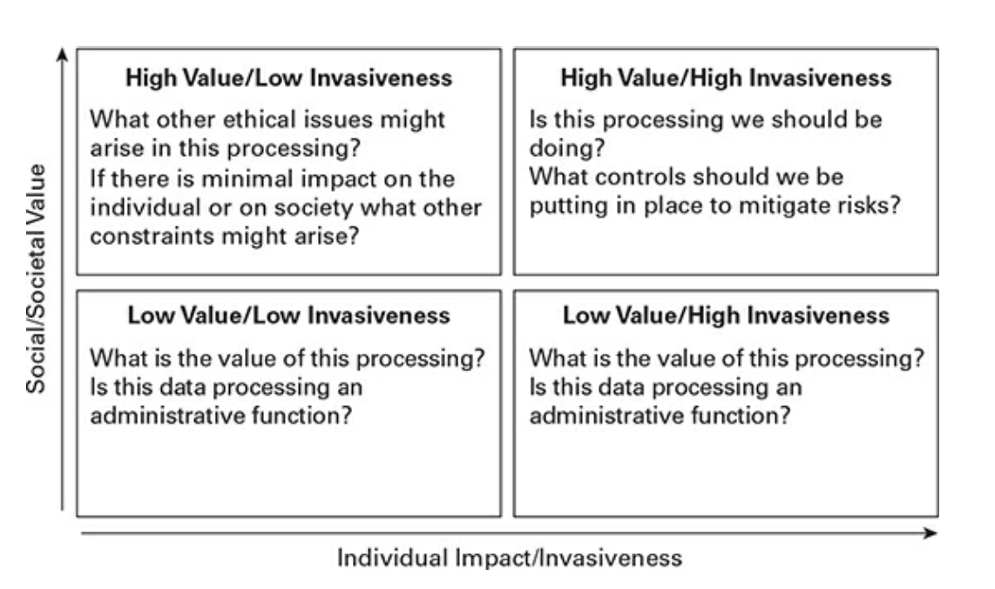
(O’Keefe and O’Brien, 2023)

Consider the two examples below and identify in which part of O’Keefe and O’Brien’s Invasiveness vs. Impact matrix the technology fits into explaining your rationale. For each example think about what controls could be put in place to mitigates risks of invasive data processing.

Example 1 - Health Monitoring App
A national health app collects individuals’ heart rate and location data to detect early signs of heart issues for individuals but also to track national trends of heart disease.
Example 2 Retail Behaviour Tracking
A supermarket chain tracks customers’ purchases as well as their movements in-store through a digital loyalty card to optimise shelf layouts and increase sales.

Submit a PDF file to Brightspace by Sunday 1st February 2026 11.30pm
** Please use APA referencing and citations to reference news articles or literature and if you use GenAI include a description of how you used it including promts.

